**Http**

Исходный код проекта:

<https://github.com/verkhoumov/AndroidLabs/tree/master/Http>

Скриншоты экрана:

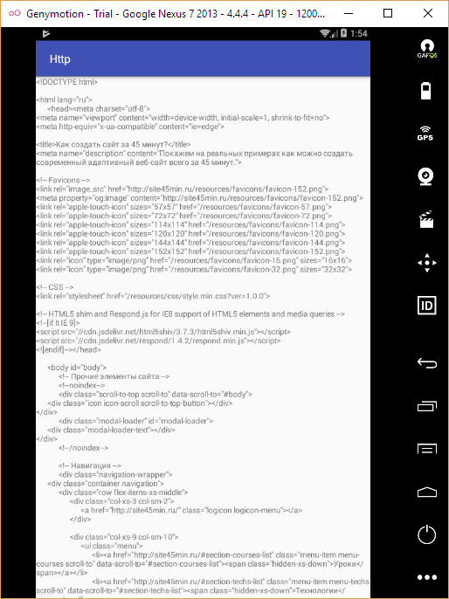

Исходный код.

ProgressFragment.java:

1. **package** ru.verkhoumov.http;

4. **import** android.os.AsyncTask;
5. **import** android.os.Bundle;
6. **import** android.support.v4.app.Fragment;
7. **import** android.view.LayoutInflater;
8. **import** android.view.View;
9. **import** android.view.ViewGroup;
10. **import** android.widget.TextView;
11. **import** android.widget.Toast;
13. **import** java.io.BufferedReader;
14. **import** java.io.IOException;
15. **import** java.io.InputStreamReader;
16. **import** java.net.HttpURLConnection;
17. **import** java.net.URL;
19. **public** **class** ProgressFragment **extends** Fragment {
20. **public** TextView contentView;
21. **public** String contentText = **null**;
23. @Override
24. **public** **void** onCreate(Bundle savedInstanceState) {
25. **super**.onCreate(savedInstanceState);
26. setRetainInstance(**true**);
27. }
29. @Override
30. **public** View onCreateView(LayoutInflater inflater, ViewGroup container, Bundle savedInstanceState) {
31. View view = inflater.inflate(R.layout.fragment_progress, container, **false**);
32. contentView = (TextView) view.findViewById(R.id.content);
34. **if** (contentText != **null**) {
35. contentView.setText(contentText);
36. }
38. **return** view;
39. }
41. @Override
42. **public** **void** onActivityCreated(Bundle savedInstanceState) {
43. **super**.onActivityCreated(savedInstanceState);
45. **if** (contentText == **null**) {
46. **new** ProgressTask().execute();
47. }
48. }
50. **class** ProgressTask **extends** AsyncTask<String, Void, String> {
51. @Override
52. **protected** String doInBackground(String... path) {
53. String content;
55. **try** {
56. content = getContent("http://site45min.ru");
57. } **catch** (IOException e) {
58. content = e.getMessage();
59. }
61. **return** content;
62. }
64. @Override
65. **protected** **void** onPostExecute(String content) {
66. contentText = content;
67. contentView.setText(content);
69. Toast
70. .makeText(getActivity(), "Данные успешно загружены", Toast.LENGTH_SHORT)
71. .show();
72. }
74. **private** String getContent(String path) **throws** IOException {
75. BufferedReader reader = **null**;
77. **try** {
78. *// Формируем ссылку для запроса.*
79. URL url = **new** URL(path);
81. *// Открываем новое http-соединение.*
82. HttpURLConnection c = (HttpURLConnection) url.openConnection();
84. *// Настраиваем соединение.*
85. c.setRequestMethod("GET");
86. c.setReadTimeout(10000);
87. c.connect();
89. *// Читаем данные по ссылке.*
90. reader = **new** BufferedReader(
91. **new** InputStreamReader(c.getInputStream())
92. );
94. StringBuilder buffer = **new** StringBuilder();
95. String line;
97. **while** ((line = reader.readLine()) != **null**) {
98. buffer.append(line + "**\n**");
99. }
101. **return** buffer.toString();
102. } **finally** {
103. **if** (reader != **null**) {
104. reader.close();
105. }
106. }
107. }
108. }
109. }

fragment_progress.xml:

1. **<?xml** version="1.0" encoding="utf-8"**?>**
2. **<RelativeLayout**
3. xmlns:android="http://schemas.android.com/apk/res/android"
4. android:layout_width="match_parent"
5. android:layout_height="match_parent"**>**
7. **<ScrollView**
8. android:layout_width="match_parent"
9. android:layout_height="match_parent"**>**
11. **<TextView**
12. android:layout_width="match_parent"
13. android:layout_height="wrap_content"
14. android:id="@+id/content"
15. android:text="Загрузка данных..." **/>**
16. **</ScrollView>**
17. **</RelativeLayout>**

activity_main.xml:

1. **<FrameLayout** xmlns:android="http://schemas.android.com/apk/res/android"
2. android:layout_width="match_parent"
3. android:layout_height="match_parent"**>**
5. **<fragment**
6. android:id="@+id/contentFragment"
7. android:layout_width="match_parent"
8. android:layout_height="match_parent"
9. android:name="ru.verkhoumov.http.ProgressFragment" **/>**
10. **</FrameLayout>**